**Table 1: “**Parallel-Trends” Regression

1.a) Number of Hospitalization for control states

|  |  |
| --- | --- |
|  | Lung Hospitalization |
| Year | 45.5*** |
|  | (16.6) |
| Observations | 297 |
| *R*2 | 0.025 |

Standard errors in parentheses

* p<0.1, ** p<0.05, *** p<0.01

1.b) Number of Hospitalization for treatment states

|  |  |
| --- | --- |
|  | Lung Hospitalization |
| Year | 51.7*** |
|  | (17.5) |
| Observations | 253 |
| *R*2 | 0.034 |

Standard errors in parentheses

* p<0.1, ** p<0.05, *** p<0.01

**Notes:** By these numbers, we see that the slopes between control states and treatment states before the treatment year (2021) was similar, and we can observe that the slopes are most likely parallel. To confirm further, we use the canonical DnD line graph.

**Figure 1:** DnD line graph

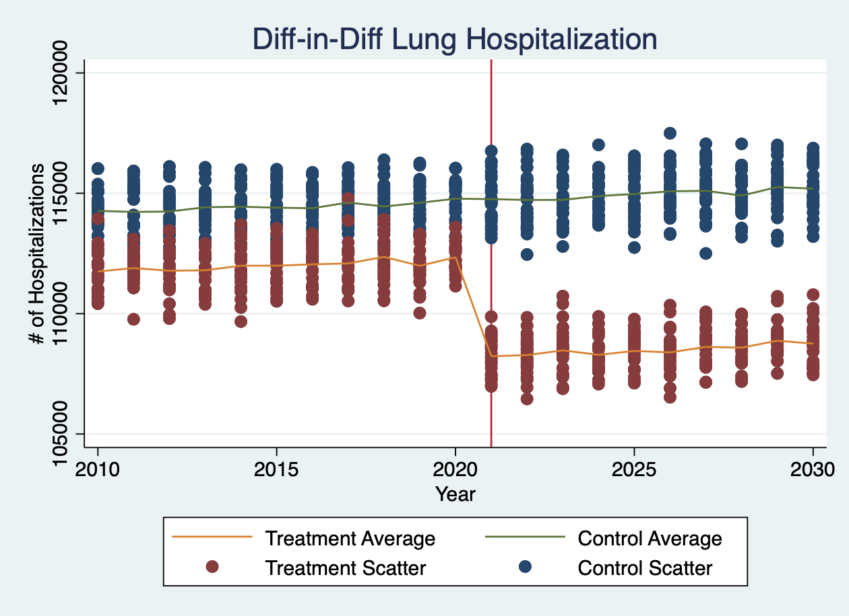

**Notes:** Based on these graphs, we can ascertain that the slopes are in fact parallel between the averages in treatment and control.

**Table 2**: Effect of Treatment (Vaping Ban) on Lung Hospitalization

|  |  |
| --- | --- |
|  | Lung Hospitalization |
| Group Designation | -4,918*** |
|  | (166) |
| Before/After Treatment | 975*** |
|  | (110) |
| Diff-in-Diff Measure | -4,030*** |
|  | (65.4) |
| Observations | 1050 |
| *R*2 | 0.963 |

Standard errors in parentheses

* p<0.1, ** p<0.05, *** p<0.01

**Notes**: This table contains regressions predicting number of lung hospitalization as a function of whether subjects were in control or treatment condition states (1 or 0), before or after treatment (1 or 0), and the interaction between treatment states and vaping ban. Standard OLS standard errors are reported (166, 110, 65.4, respectively). The table also shows that the dataset had 1050 observations. States and year were controlled as fixed effects.

Here we see that being in the treatment condition (states with vaping ban) regardless of treatment period caused a decrease in the amount of those hospitalized due to lung-related hospitalization. Secondly, comparing time period between before and after treatment, there were more lung-related hospitalizations. However, there was a significant decrease of lung-related hospitalization in the states that implemented a vaping ban when compared the non-treatment period and control group ($β=-4,030, p<0.01$). Ultimately, we can conclude that the vaping ban has a causal relationship in reducing the amount of lung-related hospitalization when controlled for the specific characteristics of the state or year of observation.